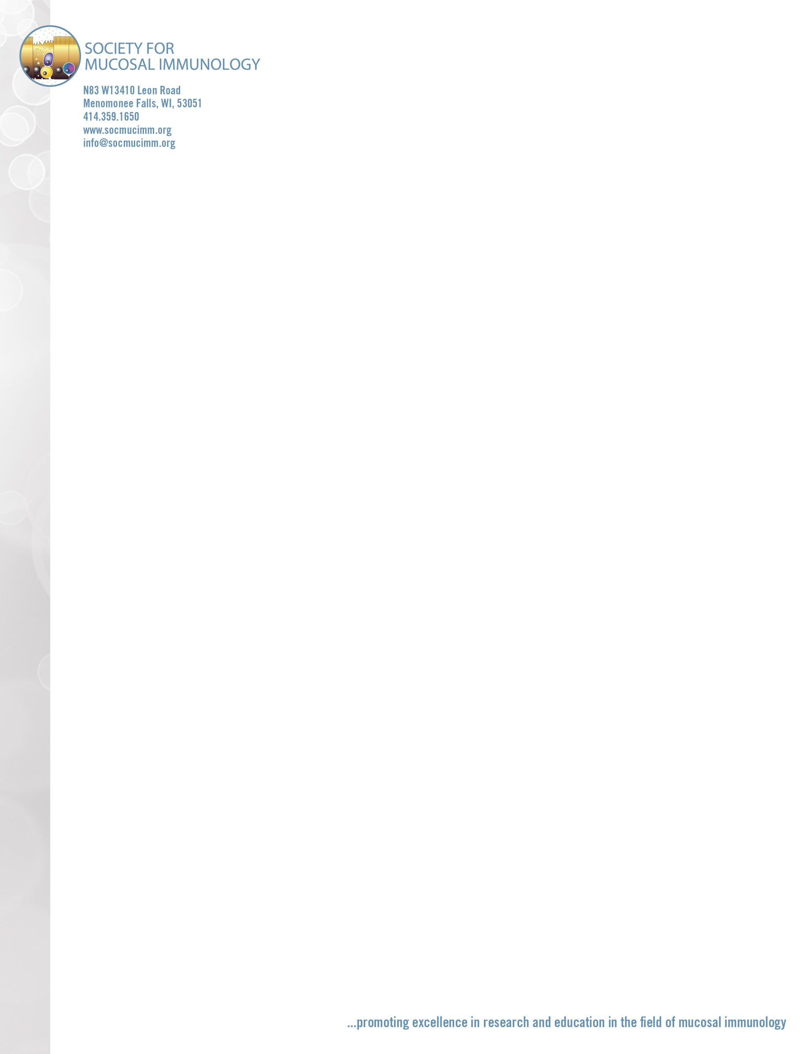

DATE

<MAILING ADDRESS LINE 1>

<MAILIING ADDRESS LINE 2>

<CITY, STATE/REGION, COUNTRY>

<POSTAL CODE>

Dear <FIRST & LAST NAME>,

The Society for Mucosal Immunology (SMI) extends this official letter of invitation to you to attend the International Congress of Mucosal Immunology (ICMI 2019) in Brisbane, Australia, on July 17-20, 2019.

I am happy to confirm that we have received your abstract submission and look forward to your presentation.

ICMI is the only international meeting that focuses exclusively on the interface between the immune system and the environment at mucosal surfaces. It is the perfect occasion for cross-fertilization between basic scientists, clinical researchers and industry professionals working on pathways of immunity and inflammation at mucosal surfaces.

Should you have any questions or concerns you may contact us by email, phone or fax.

Stay tuned for additional information (including the final program) by visiting the SMI website at [**socmucimm.org**](http://www.socmucimm.org). I also encourage you to register as quickly as possible – early-bird registration closes on May 14, 2019!

Sincerely,  
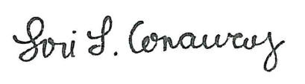

Lori L. Conaway  
SMI Executive Director

Society for Mucosal Immunology  
N83 W13410 Leon Road  
Menomonee Falls, WI 53051  
P: (414) 359-1650 / F: (414) 359-1671